**CRYPT HUNT DOCUMENTATION**

1. Ques : “Carefully observe everywhere and then write answer”

Ans: Answer

1. Ques: That tattoo on your arm.

-.-. / --- / -. / --. / .-. / .- / - / ..- / .-.. / .- / - / .. / --- / -. / ...

Ans: John F Kennedy

The Morse code when translated will yield the answer “Congratulations.” Upon googling congratulations, the user will find number of links. But there is a song named congratulations by Post Malone. “That tattoo on your arm”, is a hint. When they read about Post Malone, they would find he has a tattoo of johnfkennedy.

1. Ques:



This picture will be there and an audio that says “Thanks”.

Ans: Osmgaming

The audio will just say “Thanks.”. And this picture will be there. They will have to find the youtube video that says thanks and has this frog as the thumbnail. It is a very short 2s video. Once they find this youtube video. They will have to write the channel’s name, i.e., Osmgaming.



Ans: bees

On scanning the QR code, they will find the sentence.

“Dumbells are used by experianced and persevarant fitness freak.”

There are spelling errors.

Dumbbells – missing b.

Experienced – missing e

Perseverant- missing e

Freak- missing s

1. ❑︎◆︎♋︎❒︎⧫︎♏︎❒︎ ◻︎♋︎⬧︎⧫︎

Ans: trojanwar

On solving the windings alphabets, we get “Quarter past”. It’s is a song from the fall of troy band.(not very easily traceable with the help of quarter past.)Fall of troy has an ancient meaning, Trojan War.

1. 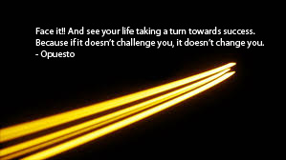

Ans : Courageous.

There is yellow streak in the picture. Yellow streak is a phrasal verb(not many know) that means timid. Also people won’t identify the yellow streak easily also. They will look at the quote first. The word Opuesto is not a person . It is the Spanish for opposite. So opposite of yellow streak is someone who is courageous.

1. 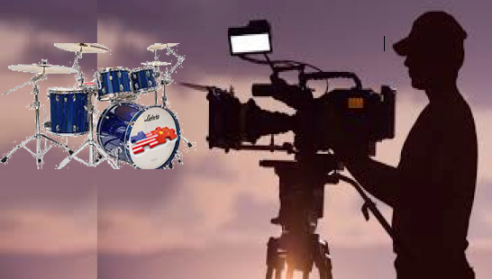

Ans : james wong howe

There are three things if the person is observant. A person with the videocam , drums and flag.There is a movie called Drums of fate, not many know. This movie’s cinematographer is an American-chinese man called james wong howe. In this url of this question we can probably write “destiny.”(it has not been done yet.) Destiny is synonym of fate. This will hint the person

1. 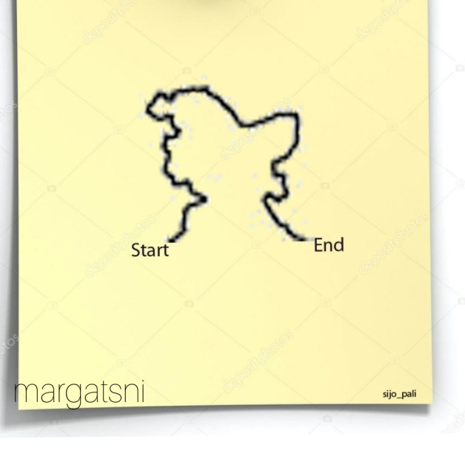

Ans: <https://instagurum.com/media/BYFzwvSnZBI>

The above picture has a start and an end. It shows a map with the start and an end. On careful observation one can figure out that this is the map of Jammu and Kashmir. On careful observation one can also see the name sijo_pali at the bottom right. margatsni when reversed is instagram. Therefore they have to find a jammu Kashmir pic by sijo_pali on his pininterest and give its url.

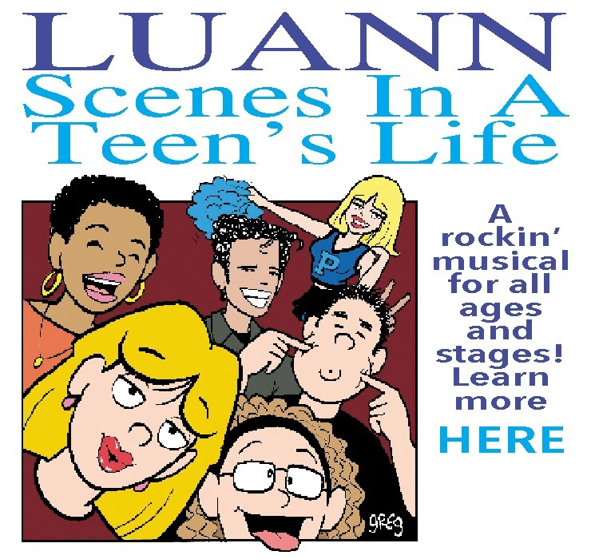

Can you lend me the picture of sisters who are not happy?

Ans: George bush virus

Sisters who are not happy will be grim. This will lead to “The Sisters Grimm” which is a children’s fantasy series written by Michael Buckley and illustrated by **Peter Feruson.**

Luann in the pic and opposite of lend ie borrow; will lead him to Lu Ann Barrow.

Searching both Lu Ann Barrow and Peter Ferguson he will be lead to National book festival. It was founded by Laura Bush, wife of George Bush.

1.  CLICK ME

When the user clicks click me she is directed to another page with the pic.

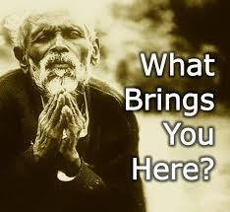

Ans: URL

The L in the picture represents L of url while U in the second picture represents you.

1. The most difficult part of the conundrum was discovered.

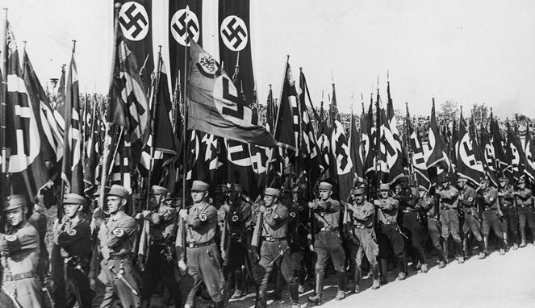

Ans: bletchley park

Conundrum means a difficult problem/question. If we trace back the picture, it shows the era of Nazism. There were several problems associated with this era. But the word solved, refers the enigma code. The enigma code machine was built here. This place Bletchley park is also the home of codebreakers.

1. "The greatest enemy of knowledge is not ignorance, it is the illusion of knowledge"

Ans: george and the blue moon

1. 

In the beginning…Was the command line

Ans: break the code.

In the beginning… Was the command line is a novel by Neal Stephenson. The person will have to look for other novels by him and reach the novel: snow crash. The ice in the picture will hint him which novel is to be chosen. The image also has “break the ice”, which will hint him to find a similar sentence in the novel snow crash i.e break the code.

1. 

Order for. Order from

Ans : Ofbusiness

The above picture is of a person called Nitin Jain. He started a company called Ofbusiness who’s moto says order for. Order from.

1. 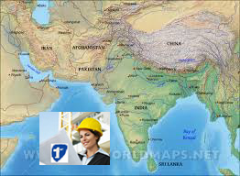

Ans : IGDTUW

The above is the map of south asia. In this map we can see a pic of a women and 1st. The answer id is IGDTUW. It is south-asia’s first women technical university.

1. 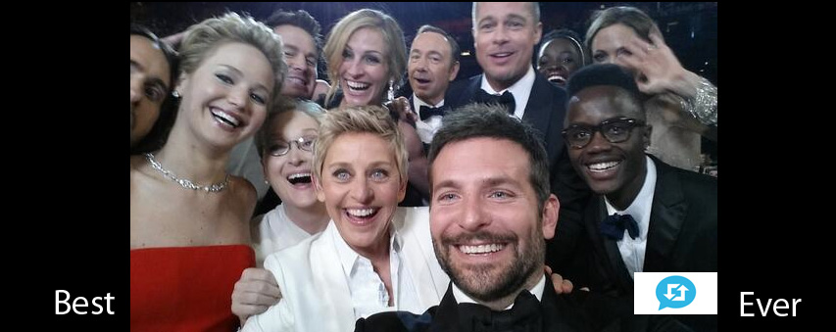

Ans: Bradley’s arm

The above pic has a small icon. This is the retweet symbol. It has been labelled as the best photo ever on twitter. We have best and ever on either side of the photo. The key phrase of this photo is bradley’s arm.

1. Billions of breeds with sesame seeds.

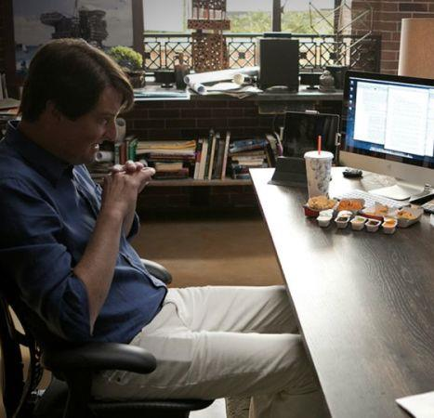

Ans : burger king

The above is the image from Silicon Valley season 1 episode 3 where the subplot was of Burger king and the question was the line said.

1. Ans : NIUE

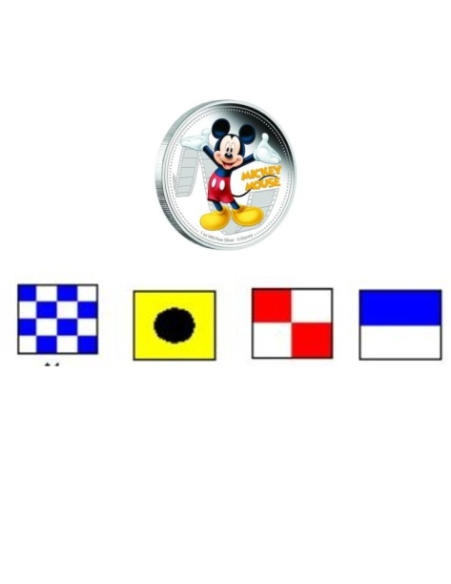

The coin is the currency of country Niue. Flags are the encryption of word NIUE